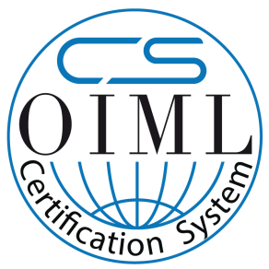 | [Insert Logo of OIML Issuing Authority]
OIML Member State  ……………………. | OIML Certificate No.  ……………………...
OIML CERTIFICATE ISSUED UNDER SCHEME A/B [delete as appropriate]
OIML Issuing Authority
Name:……………………………………………………………………………………
Address:…………………………………………………………………………………
Person responsible:………………………………………………………………………
Applicant
Name:……………………………………………………………………………………
Address:…………………………………………………………………………………

Manufacturer
Name:……………………………………………………………………………………
Address:…………………………………………………………………………………

Identification of the certified type (the detailed characteristics will be defined in the additional pages)
……………………………………………………………………………………
……………………………………………………………………………………

Designation of the module (if applicable)
……………………………………………………………………………………

This OIML Certificate attests the conformity of the above identified type (represented by the sample(s) identified in the OIML type evaluation report) with the requirements of the following Recommendation of the International Organization of Legal Metrology (OIML):

OIML R …… Edition (year): ……

For accuracy class (if applicable): ………

OIML Certificate No.
……………………...
This OIML Certificate relates only to metrological and technical characteristics of the type of measuring instrument covered by the relevant OIML Recommendation identified above.

This OIML Certificate does not bestow any form of legal international approval.

The conformity was established by the results of tests and examinations provided in the associated OIML type evaluation report:
No. …………………… dated …………………… that includes ……….. pages
The technical documentation relating to the identified type is contained in documentation file:
No. …………………… dated …………………… that includes ……….. pages
OIML Certificate History
Revision No. | Date | Description of the modification
Identification, signature and stamp
The OIML Issuing Authority
……………………………..
……………………………..

Date:……………………….

Important note: Apart from the mention of the Certificate’s reference number and the name of the OIML Member State in which the Certificate is issued, partial quotation of the Certificate and of the associated OIML type evaluation report(s) is not permitted, although either may be reproduced in full.

